Core Java
James Gosling – 1995 sun microsystem @oracle
March > java 24v, September 25v (2025)
JAVA(JSE ,JEE,JME)
1. Java Standard Edition (Java SE): corejava,awt,swings,applets,jdbc
- Purpose: The foundation of Java, used for developing and deploying applications on desktops and servers. It's the most widely used edition.
- Example: calculator,notepad++,eclipse,vlc media
2. Java Enterprise Edition (Java EE): servlets,jsp,spring,spring boot
- Purpose: Designed for building large-scale, multi-tiered, and scalable network applications, especially for enterprise-level systems.
- Example: banking application or a large-scale e-commerce platform.
3. Java Micro Edition (Java ME): Android
- Purpose: Optimized for resource-constrained devices like mobile phones, embedded systems, and other small-scale devices.
- Example: mobile game, a GPS application
4. JavaFX set of libraries used for developing light weight internet rich application
Java features
platform independence,
object-oriented programming (OOP) paradigm,
robustness,
security, and
multithreading capabilities,
architecture-neutral
high-performance
It's also known for being interpreted
Imp features
Platform independent (JVM)
Garbage collector – automatically manage memory.
By removing objects (no longer referenced by running program)

Components of Java Platform
JDK(developer tools)>JRE(libraries)>JVM
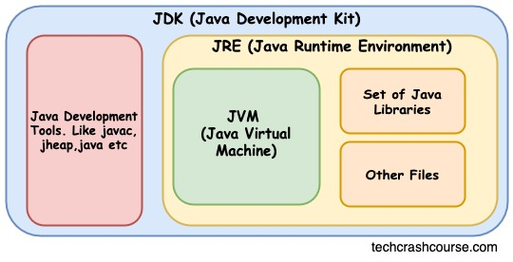
Java Execution Process
file.java------>compilation(compiler)----->byte code(ClassName.class)--àJVM---àOS execution
JVM Architecture
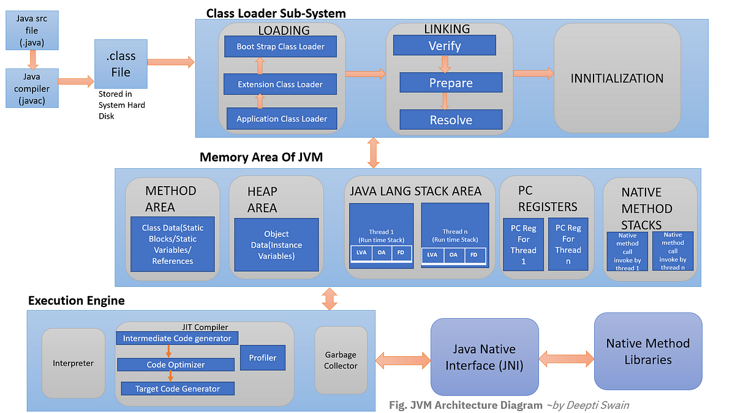
LVA - Local Variable Array OS - Operand Stack FD – Framed Data
Interpreter – line by line execution, byte code to native machine code
JIT (Just In Time) compiler - track count of method, once threshold reaches JIT compiles and generates corresponding native code for direct use
Garbage collector – collect and removes unreferenced object
Program execution starts from main method and from Right to left
Pascal case for class name
Camal case for objects,variables,methods
Identifiers - names used to identify and refer to various elements like variables, methods, classes, and interfaces (a-z A-Z 0-9 _ $) valid name
Default package file – java.lang Default Parent class – java.lang.object
Enumeration
a special data type that represents a group of named constants.
Use:
Useful for representing a fixed set of values, such as days of the week, status codes, or options in a menu, making code more readable and maintainable
They can be used in switch statements and compared using == or equals().
Syntax -> “enum” keyword similar to class but no need to use new keyword
By default enum is public static final
Can have method,variable and constructor
enum Status {
PENDING("Pending"),
PROCESSING("Processing"),
COMPLETED("Completed"),
REJECTED("Rejected");

private String description;

Status(String description) {
this.description = description;
}

public String getDescription() {
return description;
}
}

public class EnumExample {
public static void main(String[] args) {
Status status = Status.PROCESSING;
System.out.println("Order Status: " + status.getDescription());
}
}

Java variables:
Data container ->stores value
Syntax: datatype variable_name;(variable declaration)
variable_name=value;(variable initialization)

Three Types: Local, Instance and Static variable
Local variable | Instance Variable | Static Variable
Syntax: Inside the block | Inside class - outside block | Static keyword,  Inside class - outside block
Memory: stack (method exec) | Heap (object creation) | Method area(class loading)
Access: Direct | Obj.var_name | Class.var_name
Usage : block scope data | Unique data | Common data

class Guru99 {
static int a = 1; //static variable-initialized once ->class loading
int data = 99; //instance variable
void method() {
int b = 90; //local variable
}
}

Datatype->designates type & quantity of value to hold
Primitive ->fixed size, no methods or properties, faster performance, stored directly in memory without overhead associated with object reference
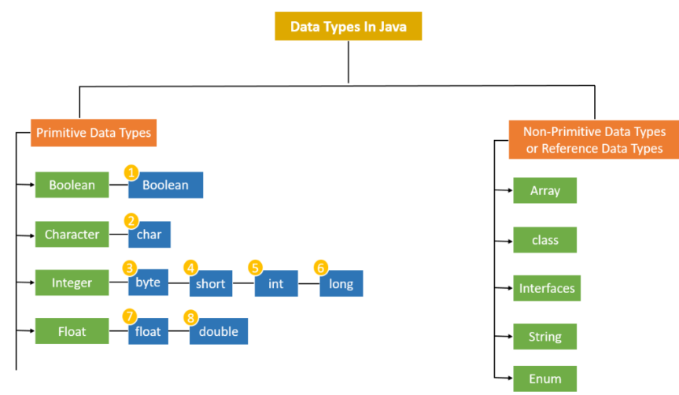
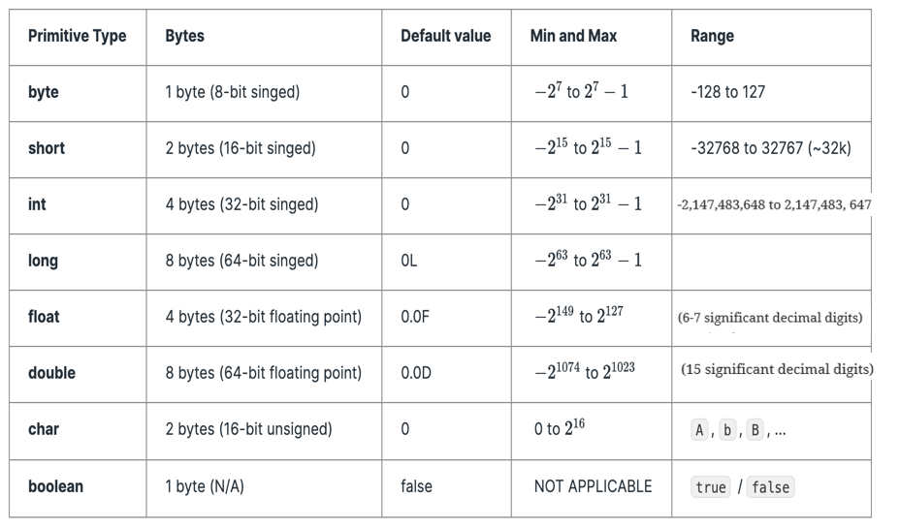
Operators:
Types of Operators in Java
- Arithmetic Operators (+, -, *, /, %)
- Unary Operators ( 002B, -, ++, --, ! )
- Assignment Operator (+=, -=, *=, /= ,%=)
- Relational Operators ( ==, != , <, <=, >, >=)
- Logical Operators( &&, ||, !)
- Ternary Operator (condition ? if true : if false)
- Bitwise Operators (&, |, ^, ~)
- Shift Operators : number shift_op number_of_places_to_shift;
- << (Left shift): Shifts bits left, filling 0s (multiplies by a power of two).
- >> (Signed right shift): Shifts bits right, filling 0s (divides by a power of two), with the leftmost bit depending on the sign.
- >>> (Unsigned right shift): Shifts bits right, filling 0s, with the leftmost bit always 0.
- instance of operator – type checking
object instance of class/subclass/interface

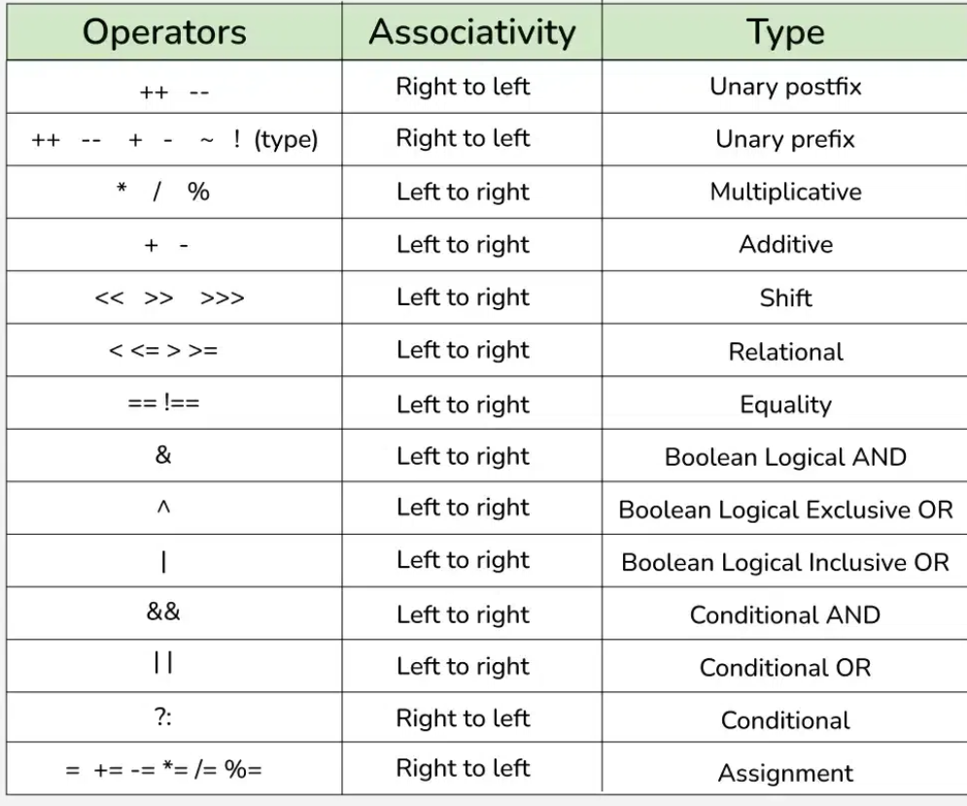
Control flow
If-else, while, do-while,
for-each for, switch(condition){case num:statement;}
default, break, continue,
do{  //statement;  }  while(condition); | for (dtype iter_name : var_name){  sopln(iter_name);  }

OOPS
Object Oriented Programming Structure ---àOOPL
Advantage->Performance and security
Class is a collection of data members and member function(virtual)
Object instance of class(physical)
Method: access_modifer static/instance type name(parameters)
class Main {
void multiply (int a,int b){
System.out.println("multiplication:"+(a*b));
}
public static void main (String args[]){
Main m=new Main ();
m.multiply(1,2);
} }
Security
Encapsulation - Binding/wrapping of data and its corresponding methods together
Abstraction - Hiding implementation details and providing essential functionalities only
Performance
Inheritance - Extending properties of one class to other
Polymorphism – ability of method or object to take many form
- Abstraction
Abstraction refers to hiding the implementation details of a code and exposing only the necessary information to the user
Achieved using abstract class or Interface
Abstract method – method without implementation (abstract keyword)
Class – only concrete methods
Abstract class – combination of concrete and abstract methods (abstract keyword)
Interface – only abstract methods (multiple inheritance & 100% abstraction achieve)
Interface - > class implements keyword
Interface -> Interface, class -> class extends keyword
Default Interface variable - public static final, methods-abstract
Java supports multiple inheritance using interface

// Abstract class representing a Vehicle (hiding implementation details)
abstract class Vehicle {
abstract void accelerate();
abstract void brake();

void startEngine() {
System.out.println("Engine started!");
}
}

// Concrete implementation (hidden details)
class Car extends Vehicle {
@Override
void accelerate() {
System.out.println("Car: Pressing gas pedal...");
}

@Override
void brake() {
System.out.println("Car: Applying brakes...");
}
}

public class Main {
public static void main(String[] args) {
Vehicle myCar = new Car();
myCar.startEngine();
myCar.accelerate();
myCar.brake();
}
}

2.Inheritance
mechanism in Java by which one class is allowed to inherit the features(fields and methods) of another class
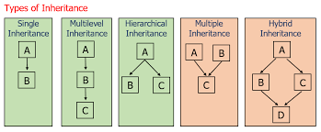
// Superclass (Parent)
class Animal {
void eat() {
System.out.println("Animal is eating...");
}

void sleep() {
System.out.println("Animal is sleeping...");
}
}

// Subclass (Child) - Inherits from Animal
class Dog extends Animal {
void bark() {
System.out.println("Dog is barking!");
}
}

public class Main {
public static void main(String[] args) {
Dog myDog = new Dog();

// Inherited methods (from Animal)
myDog.eat();
myDog.sleep();

// Child class method
myDog.bark();
}
}

3.Polymorphism
Polymorphism is the ability of an object to take on many forms. It allows a single action to be performed in different ways, achieved through method overriding (runtime polymorphism) and method overloading (compile-time polymorphism).
Method overloading Method Overriding(@Override )
Compile-Time polymorphism Run-Time polymorphism
Same name -Different method signature Same name – same method signature
Early binding late binding
// Java Program to Demonstrate
// Method Overloading and Overriding

// Parent Class
class Parent {
// Overloaded method (compile-time polymorphism)
public void func() {
System.out.println("Parent.func()");
}

// Overloaded method (same name, different parameter)
public void func(int a) {
System.out.println("Parent.func(int): " + a);
}
}

// Child Class
class Child extends Parent {
// Overrides Parent.func(int) (runtime polymorphism)
@Override
public void func(int a) {
System.out.println("Child.func(int): " + a);
}
}

public class Main {
public static void main(String[] args) {
Parent parent = new Parent();
Child child = new Child();
// Dynamic dispatch
Parent polymorphicObj = new Child();

// Method Overloading (compile-time)
parent.func();
parent.func(10);

// Method Overriding (runtime)
child.func(20);

// Polymorphism in action
polymorphicObj.func(30);
}
}

4.Encapsulation
Data hiding process ,where we use getters and Setters to access data
// Encapsulation using private modifier
class Employee {
// Private fields (encapsulated data)
private int id;
private String name;

// Setter methods
public void setId(int id) {
this.id = id;
}
public void setName(String name) {
this.name = name;
}
// Getter methods
public int getId() {
return id;
}

public String getName() {
return name;
}
}
public class Main {
public static void main(String[] args) {
Employee emp = new Employee();
emp.setId(101);
emp.setName("Geek");
System.out.println("Employee ID: " + emp.getId());
System.out.println("Employee Name: " + emp.getName());
}
}

Keywords:
This keyword: current class properties(class,object,constructor,method,variable)
Super: Parent class properties(class,constructor,method,variable)
Final: variable cannot update,method cannot override,class cannot extendable
Constructor: object creation Method:
Name Same as class name different name
Type: default/parameterized defined/parameterized
No return type return type present

Constructor
A constructor is a special method within a class that's automatically called when a new object of that class is created. Its primary purpose is to initialize the object's state by assigning initial values to its attributes or members.
Types:
1.Default Constructor:
Non-parameterized constructor automatically defined by compiler when no constructor provided.
2.Non-parameterized constructor:
It is a user-defined constructor having no arguments or parameters.
class base {
base() {
System.out.printIn(
"This is a non-parameterized constructor.");
}}
3.Parameterized constructor:
The constructors that take some arguments.
class base {
base(int a)
{
System.out.println("Constructor with argument: "+ a);
}}

4.Copy Constructor:
A copy constructor is a member function that initializes an object using another object of the same class.
class base {
int a, b;
// copy constructor
base(base& obj) {
a = obj.a;
b = obj.b;
}}

Access Modifiers
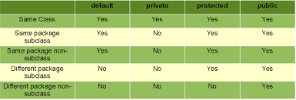

Object class:
Every class in java directly/indirectly inherited from object class.
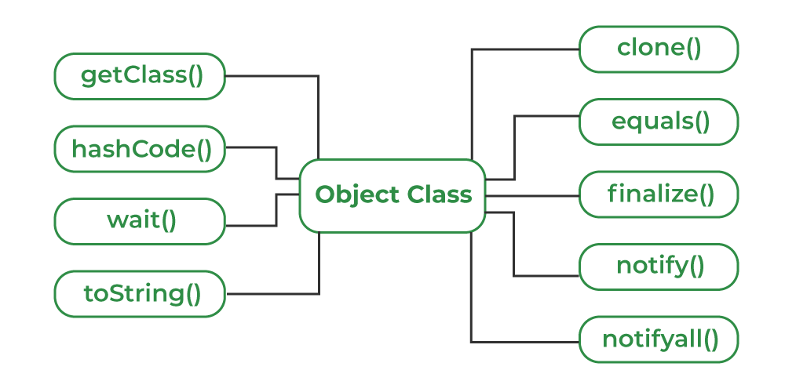
- toString() -> class name @ signed hexadecimal representation of hashcode
- hashCode() ->converts internal address of object into integer and return it
- equals() -> two object reference same content,return true or false
== -> same referrence
Str1.CompareTo(str2) ->check relative order 0,-ve (str1<str2),-ve(str1>str2) check characters
- getClass() -> returns runtime class of an object
- finalize() -> method called just before object garbage collected
- Clone() -> create and return a new object that is copy of current object
- Concurrency methods->wait() current thread release lock and wait,notify() notify only one thread ,notifyAll() notify all the waiting threads can be used in synchronized environment

Exception handling
Mechanism to handle run time errors to allow normal execution of program
Try{ //error code }
Catch(ExceptionName var){ //handling code }
Finally{ //cleanup code }
Combination:try+catch,try+multiple catch,try+catch+finally,nested try+finally
Throw keyword inside method to explicitly throw an exception at a specific point
Throws Declared in a method signature to indicate that the method may throw one or more exceptions, which must be handled by the caller (especially for checked exceptions).
Custom Exception: create a customException class extend with exception/runtimeException class
Constructor(msgParam){super(msg)}
public class InvalidAgeException extends Exception {
//if we want unchecked exception extend with RunTimeException class
InvalidAgeException(String msg){
super(msg);
}
}
public class ExceptionHandling {
static void checkEligibility(int age) throws InvalidAgeException {
if(age>=18) {
System.out.print("you're eligible");
}
else {
throw new InvalidAgeException("Age must be above 18");
}
}
public static void main(String args[]) throws InvalidAgeException,ArrayIndexOutOfBoundsException {
int arr[]= {1,2};
try {
System.out.print(arr[5]);
}
catch(ArrayIndexOutOfBoundsException e) {
System.out.println(e.getMessage());
}
finally {
System.out.println("finally block");
}
System.out.println("End of exception handling");
checkEligibility(9);
System.out.println("End of code");
}
}

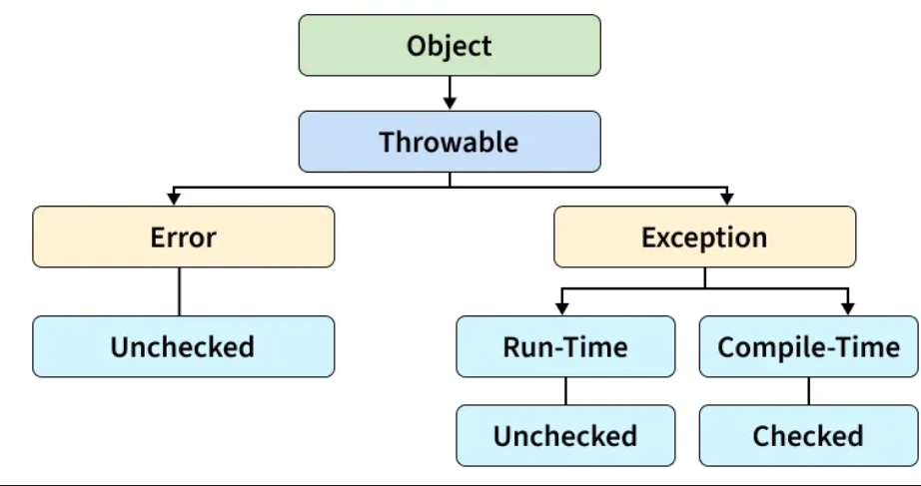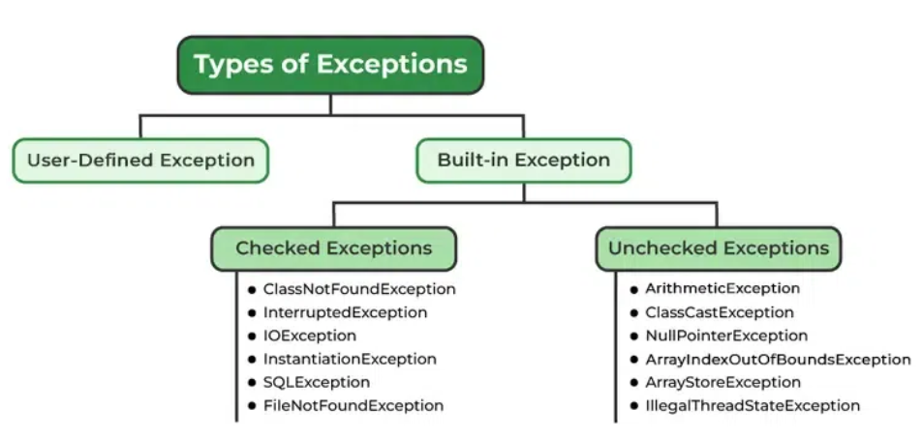
Error:OutOfMemoryError,StackOverFlowError

Generics
Generics: Parameterized type<T> - reusability & type safe
Types of Java Generics : generic class and generic methods
We can use multiple type parameter in generic classes
class Test<T, U>  {  T obj1; // An object of type T  U obj2; // An object of type U  Test(T obj1, U obj2)  {  this.obj1 = obj1;  this.obj2 = obj2;  }  public void print()  {  System.out.println(obj1);  System.out.println(obj2);  }  }  class Geeks  {  public static void main (String[] args)  {  Test <String, Integer> obj =  new Test<String, Integer>("GfG", 15);  obj.print();  }  } | class Geeks {  // A Generic method example  static <T> void genericDisplay(T element)  {  System.out.println(element.getClass().getName()  + " = " + element);  }  public static void main(String[] args)  {  // Calling generic method with Integer argument  genericDisplay(11);  // Calling generic method with String argument  genericDisplay("GeeksForGeeks");  // Calling generic method with double argument  genericDisplay(1.0);  }  }

Threads
Thread is a smallest unit of execution
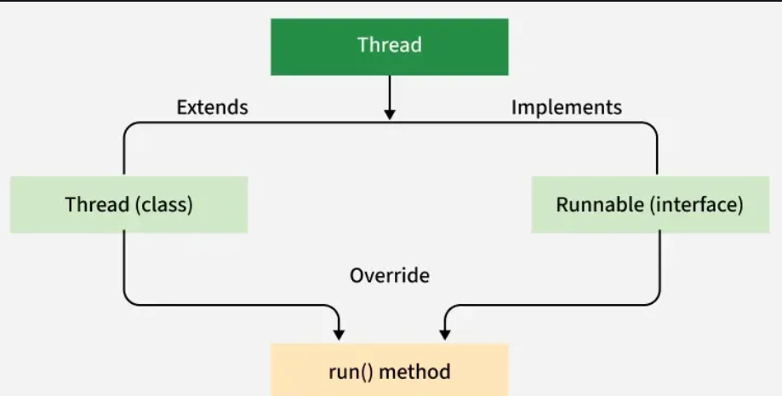
Test Extend thread class override run() place code call test.start() to start thread
Test implement runnable override run() with code create test obj create thread obj by passing test as parameter then thread.start()
Note: Extend Thread when when you don’t need to extend any other class. Implement Runnable when your class already extends another class (preferred in most cases).
>>need to know about executorService
public class ThreadCreation extends Thread{
@Override
public void run() {
System.out.println("new thread is running");
}
public static void main(String args[]) {
ThreadCreation threadCreation=new ThreadCreation();
threadCreation.start();
System.out.println("current thread");
}
}
class ThreadCreation implements Runnable{
@Override
public void run(){
System.out.println("new thread");
}
public static void main(String args[]) {
ThreadCreation threadCreation=new ThreadCreation();
Thread thread=new Thread(threadCreation);
thread.start();
System.out.println("current Thread");
}
}
Lifecycle of a thread
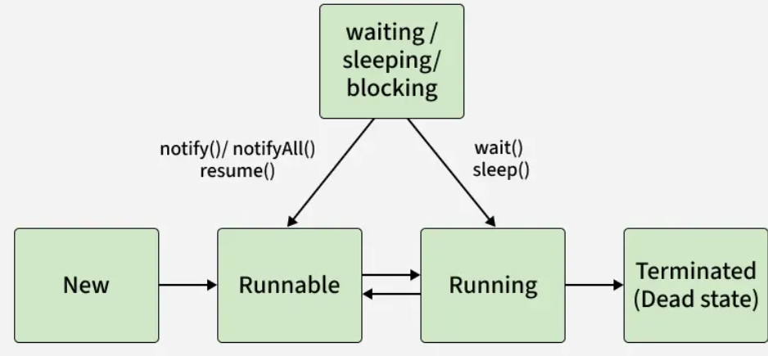
- New: Thread object is created but not started.
- Runnable: Thread is ready to run and waiting for CPU allocation.
- Running: Thread is executing its run() method.
- Waiting/Blocked: Thread waits for a resource or another thread.
- Terminated: Thread completes execution or is stopped.
Running Threads
- run() Method: Contains the code for the thread. Calling it directly behaves like a normal method call.
- start() Method: Launches a new thread and internally calls run() concurrently.
✅ 1. Thread vs Process
- Process:
  - Independent execution unit with its own memory space.
  - Heavyweight: creating a process involves allocating separate resources.
  - Communication between processes requires IPC (Inter-Process Communication).

- Thread:
  - Lightweight unit of execution within a process.
  - Shares memory and resources of the parent process.
  - Faster to create and switch compared to processes.
2. Concurrency Problems
When multiple threads run in parallel and share resources, issues arise:
- Race Condition: Two threads access and modify shared data simultaneously → unpredictable results.
- Deadlock: Two threads wait on each other’s resources → stuck forever.
- Starvation: A thread never gets CPU time because others keep hogging it.
- Livelock: Threads keep changing state to avoid deadlock but never make progress.

Race condition
class RaceCondition {
private int counter = 0;

public synchronized void increment() {
//only one thread at a time bcoz we need to read counter increament it
//then store inbetween this data can be losed
counter++; // Not atomic
}

public static void main(String[] args) {
RaceCondition demo = new RaceCondition();

Thread t1 = new Thread(() -> {
for (int i = 0; i < 1000; i++) demo.increment();
});

Thread t2 = new Thread(() -> {
for (int i = 0; i < 1000; i++) demo.increment();
});

t1.start();
t2.start();

try {
t1.join();
t2.join();
} catch (InterruptedException e) {
Thread.currentThread().interrupt();
}

System.out.println("Final counter: " + demo.counter); // Expected 2000, often less
}}
2.DeadLock
class DeadlockDemo {
private final Object lock1 = new Object();
private final Object lock2 = new Object();
public void method1() {
synchronized (lock1) {
System.out.println("Thread 1: Holding lock1...");
try { Thread.sleep(100); } catch (InterruptedException e) {}
synchronized (lock2) {
System.out.println("Thread 1: Holding lock2...");
}
}
}
public void method2() {
synchronized (lock2) {
System.out.println("Thread 2: Holding lock2...");
try { Thread.sleep(100); } catch (InterruptedException e) {}
synchronized (lock1) {
System.out.println("Thread 2: Holding lock1...");
}
}
}
public static void main(String[] args) {
DeadlockDemo demo = new DeadlockDemo();
new Thread(demo::method1).start();
new Thread(demo::method2).start();
}
}
3.Starvation
Thread high = new Thread(() -> {
while (true) System.out.println("High priority thread");
});
Thread low = new Thread(() -> {
while (true) System.out.println("Low priority thread");
});
high.setPriority(Thread.MAX_PRIORITY);
low.setPriority(Thread.MIN_PRIORITY);
high.start();
low.start();
Why? Low priority thread may rarely run on some schedulers.
Thread state
class ThreadLifecycleDemo extends Thread {
public void run() {
System.out.println("Thread is running...");
try { Thread.sleep(500); } catch (InterruptedException e) {}
System.out.println("Thread finished.");
}
public static void main(String[] args) throws InterruptedException {
ThreadLifecycleDemo t = new ThreadLifecycleDemo();
System.out.println("State before start: " + t.getState()); // NEW
t.start();
System.out.println("State after start: " + t.getState()); // RUNNABLE
Thread.sleep(100);
System.out.println("State while sleeping: " + t.getState()); // TIMED_WAITING
t.join();
System.out.println("State after finish: " + t.getState()); // TERMINATED
}}

Java25 features outline

